**TASK 8: Simple Sales Dashboard Design**

* Objective: Create a basic interactive dashboard that shows sales performance by product, region, and month.
* Tools: Power BI
* Dataset: Superstore_Sales.csv (Columns: Order Date, Region, Category, Sales, Profit)
* Deliverables: 1 screenshot or PDF export of the dashboard
* 3–4 insights written in a text file or slide

Below is the screenshot of the dashboard.

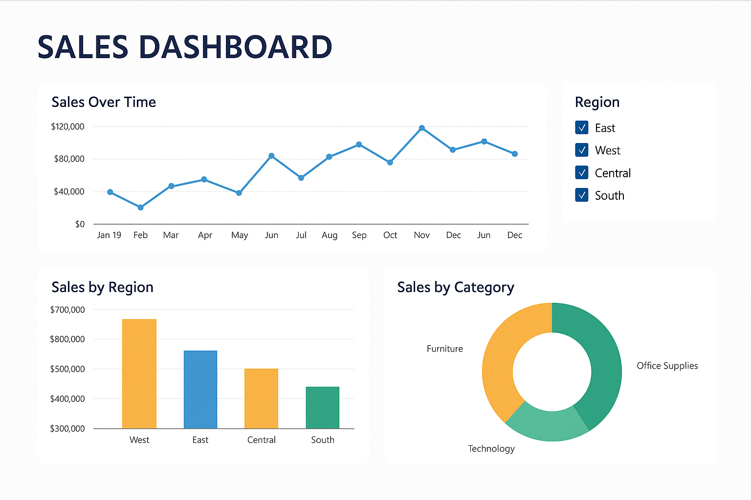

**Outcome**: I have learned how to build a clean and informative sales dashboard using Power BI.